mobiVUE PMMS (Pharmaceutical Manufacturing Management System)




Ajanta Pharma Limited
Software Requirement Specification (SRS)

Project ID:
Prepared By: Leena
The document details the summary of solution architecture and approach for the development of mobiVUE PMMS (Pharmaceutical Manufacturing Management System) for Ajanta Pharma Limited. The document is based on the inputs, system study, discussions and meeting held between BCI & Ajanta Pharma Teams.
Submission Date:
Version: 1.0
BAR CODE INDIA, 691 Udyog Vihar Phase V, Gurugram, Haryana-122016, PH: 0124 4337555

REVISION NO. | DATE | PREPARED BY | REVIEWED BY | COMMENT
1.0 |  | Leena |  | SRS Document for Ajanta Pharma Limited.
  - REVISION HISTORY

Abbreviations:
Name | Abbreviation
Microtek International Pvt. Ltd. | Microtek
Bar Code India | BCI
Fixed Mount Scanner | FMS
Handheld Terminal | HHT
Systems, Applications & Products in Data Processing | SAP

  - Table of Contents
1 Specification Organization 1
2 Introduction 2
2.1 Intended Audience and Reading Suggestions 2
2.2 Project Scope 3
3 Software/Hardware Requirements 4
3.1 Plant Server (Both DB and Application) 4
3.2 Desktop Computers 4
3.3 Hardware Requirements 4
4 Solution Architecture 5
5 User Interface Specification Conventions 6
6 System Log 7
6.1 Error Logs 7
6.2 Audit Logs 7
7 Architectural Design 8
7.1 Web Services 8
7.2 Device Application 8
7.3 Web Application 8
7.4 Scheduler Application 8
8 Application Modules 9
8.1 User Management 10
8.1.1 User Master 10
8.1.2 Role Management/ Permission 11
8.1.2 Password Management 11
8.2 Masters 12
8.2.1 Plant Master 12
8.2.2 Department Master 13
8.2.3 Area Master 13
8.2.4 Cubicle Master 14
8.2.5 Locations Master 14
8.2.6 Equipment Master 15
8.2.7 Handling Master 15
8.2.8 Gates Master 16
8.2.9 Checklist Type Master 17
8.2.10 Checklists Master 17
8.2.11 Weighing Balance Master 18
8.2.12 Standard Weight Boxes Master 18
8.2.13 Standard Weight Master 18
8.2.14 Unit of Measurements Master 18
8.2.15 Devices Master 18
8.2.16 Activity Master 18
8.4 Vendor Portal 19
8.4.1 Label Printing 19
8.4.2 Secondary Packing 21
8.4.3 Dispatch 22
8.5 Identification Operations 24
8.5.1 Location Marking 24
8.5.2 Bin Identification 26
8.5.3 Machine Identification 27
8.5.4 Pallet Identification 28
8.6 RM Operations 29
8.6.1 Receiving 29
8.6.2 GRN Cancellation And Remapping 31
8.6.3 Quality Check- Sampling 33
8.6.4 Quality Check Status 35
8.6.5 Putaway 37
8.6.6 Picklist Generation 39
8.6.7 Picking 41
8.6.8 Issuance 43
8.6.10 Shop Floor Return 45
8.6.11 Material Movement 47
8.7 FG Warehouse Operation 49
8.7.1 Receiving 49
8.7.2 Putaway 50
8.7.3 Picklist Generation 52
8.7.4 FG Picking 54
8.7.5 FG Dispatch 56
8.8 Reports 58
9 SRS Scope Change Process 59
9.1 Before Sign Off 59
9.2 After Sign Off 59
9.3 SRS Acceptance 59

Specification Organization
The objective of this document is to supply underlying concepts, procedures, and formats used in the design, development and installation of this software application. This specification consists of three sections organized as follows:
Section 1: Introduction

This section provides hardware requirements and documentation conventions.

Section 2: User Interface

This section depicts screen design and logic flow, and is categorized into two groups:
- Application Function Module
- Common Routine

Section 3: System Architecture
This section provides information of system architecture.

Introduction

Intended Audience and Reading Suggestions
The scope of this document is to provide the understanding of this solution to user & development teams associated with the application development & implementation.
This document major emphasizes on providing clear understanding of mobiVUE PMMS
This solution comprises of:
- Web Application
- Mobile Device Application
- Web Services
- SAP Interfaces

Project Scope mobiVUE PMMS
The project scope is to develop and implement the Automation System at Warehouse, Manufacturing and Finish Goods for Ajanta Pharma Limited, the solution will facilitate user to manage the storage of inventory at warehouse and also helps in efficient allocation of Material for Sampling and Dispensing. Barcode Labels will be generated for the received Material Packaging i.e. Containers or Bags against the Gate Entry Number; the application also provides identification for Equipment, Dispensing Booths, Weighing Machine, In-process machines, Pallets, Trolleys and process/dispensing rooms.
The application will be integrated with the Weighing Machine which will help to capture weight automatically, this help as it provides control on inventory as no wrong Material or quantity can be issued.
The system will be integrated with the SAP and will control the flow of information from application to database and vice- versa. Each and every transaction will be recorded along with the time stamp which will help user to access any process related information as and when required.
This would require development of Wi-Fi enabled application for real time transaction i.e. the data will be captured in real-time, once the data has been collected, the database can then provide useful reports about status of material.
The entire solution consists of followings:
- Web Application
- Mobile Device Application
- Web Services
- SAP Interface with PI Server

Software/Hardware Requirements
Below are the hardware and the software requirements of the application:
*TO BE CHANGED AS PER APPLICATION REQUIREMENT

Plant Server (Both DB and Application)
The solution would require the high performance server with minimum following:
Server will be placed as 1 for prod & 1 for DEV/QA
Descriptions | Qty
HPE DL20 Gen10 4SFF SERVER :  1 x INTEL XEON E-2136 6C 3.3GHz Processor  rail kit, 1xLP riser, HP drive cage | 1
HPE 16GB 2Rx8 PC4-2666V-E STND Kit | 2
HPE 1TB SATA 7.2K SFF SC DS HDD | 2
HPE 500W FS Plat Hot Plug LH Power Supply Kit | 2
3years 4hour response 24x7 warranty | 1

Desktop Computers
Desktop would require following specifications:-
- I3/i5 Processor with Windows 7 operating System
- 16 GB RAM
- 100GB HDD
- Dot net Framework 4.0

Hardware Requirements
Hardware required for the application:
- Android Mobile Device
- Zebra Barcode Label Printer

Solution Architecture

User Interface Specification Conventions
This section specifies the user interface portion of the application.

Section Organization
The User Interface Specification presents screen displays or “Dialogs”.
Documentation Conventions
This section incorporates illustrations of the application user interface. Each screen display “Dialog” consists of the screen display image, a process name, a paragraph documenting the processing required for the dialog, a paragraph listing the navigation options, and a table listing for each variable field on the dialog, its database source or destination, format, and any instructions required to process the field.
The following section contains a sample dialog with each area identified.

System Log
System shall maintain internal logs for application.

Error Logs
These logs will contain any errors encountered during runtime for faster resolution of any problem post deployment.

Audit Logs
These logs will monitor the activities of user who accessed the application, made changes to File/ Document and the time stamp of these activities.

Architectural Design
*TO BE CHANGED AS PER SYSTEM REQUIREMENT
Overall System consists of:
- Web Application
- Device Application
- Web Services

Web Services
This application will handle the device request in real time. Most of business logic on scanning will run on this module. Web Service will be hosted in IIS Services, Web Services will run on central server.

Device Application
This application will include warehouse process modules. Application will directly communicate with user input and process the request to communication server.

Web Application
A Web Application will be developed using which users will create the master data, download details from SAP, prints item barcode label etc. It also helps to generate and display related transaction reports to End Users in real time.

Application Modules

User Management
The module will let application administrator to manage the Users, and the rights assigned to the same; the rights will define authorized application access of users.
The User Management & Master data will be created using Web Application.

User Master
This module will let user to create application users who will access the application. To keep the system secured and track activities done by different users, user need to be registered to the system. PMMS provides following functionalities to manage users. User master will be integrated with Active directory of customer.
The master will store the users’ details in system.
Note: Super user / Super Admin is a special user which is seeded during PMMS hosting and not created using the PMMS UI.
Data Fields | - First Name  - Last Name  - Phone Number  - Select Designation  - Select Mode  - Select Sub Plant  - Select Reporting Manager  - Employee Code  - Email  - Password  - Confirm Password  - Is Active  - Role
Process Steps | - Enter required details such as First Name, Last Name, and Phone Number.  - Select Designation, Mode, Sub Plant, and Reporting Manager from dropdown.  - Enter Employee Code, Email, Password, Confirm Password.  - Select Status as Is Active if it is active.  - Select Role that need to assign to the user from the checklist.  - Click on Add button to save details in database.  - Newly added user will appear in data grid
Functions | - Add, edit/update, delete as per requirement  - Employee Code and Password is used to access the application.
Role | Admin will create/ add user details via window application

Role Management/ Permission
This module will let admin to assign access of particular Role in the application. Once assigned, authorized users can access the application. Once permissions are assigned, user will be able to view only Modules-Sub Modules of Role which he has been given access rights to by Admin.
Data Fields | - Role Name  - Display Name  - Description  - Is Active  - Permissions
Process Steps | - Admin will enter the Role Name, Display Name, and Description.  - Select Status as Is Active if role is active.  - Select the Permission by clicking on Module-Sub modules names in data grid.  - Admin will check the checkbox against Module-Sub module to which selected User should be assigned access permissions.  - Save and Update the details in database
Functions | Add, edit/update Roles as per requirement
Role | Admin will assign Roles to the selected User.

Password Management
This module will let Admin reset the password of application users if the user forgets the password. Once the password get reset by admin, then admin will share the password with the user and authorized users can access the application.
Data Fields | - First Name  - Last Name  - Employee Code  - Password  - Confirm Password
Process Steps | - Admin will enter the First Name, Last Name, and Employee Code of the user whose password needs to Reset.  - Enter the password and confirm the Password.  - Admin can see the Status of User is changed pending to Submitted.  - User will use the password reset by Admin and user has to set his new password and login again. (New password will valid for 90 days.)  - Admin can see the Status of User is changed Submitted to Completed.  - Save and Update the details in database.
Functions | Reset password of users as per requirement.

Masters

Plant Master
The master module will be used to create/update the Plant Master details in database. Different Plants in the organization will be mentioned here.
Data Fields | - Plant ID  - Plant Description  - Select Plant Type  - Is Active  - Tax Reg. No  - License  - GS1 Prefix  - Address1  - Address2  - Postal Code  - City  - State  - Country  - Email  - Phone Number  - Website
Process Steps | - Enter Plant ID.  - Enter Plant Description.  - Select Plant Type from dropdown i.e. Master Plant/ Sub Plant. (If Sub Plant is not present then enter Plant ID).  - Select Status as Is Active if it is active.  - Enter all details such as Tax Reg. No, License, GS1 Prefix, Address1, Address2, Postal Code, City, State, Country, Email, Phone Number, Website.  - Save the details in database.
Functions | Add, edit/update and delete Plant details as per requirement.
Sample Screen Design | 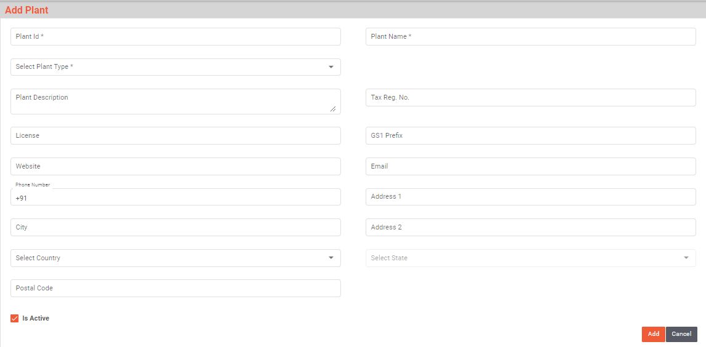

Department Master
This master will contain Department details which will define department in plants. With the help of this master.
Data Fields | - Department Code  - Select Sub Plant  - Department Name  - Department Description  - Is Active
Process Steps | - System will generate a unique code for Department Code.  - Select Sub Plant from dropdown.  - Enter Department Name and Description.  - Select Status as Is Active if it is active.  - Save the details in database.
Functions | Add, edit/update and delete Department details as per requirement.
Sample Screen Design | 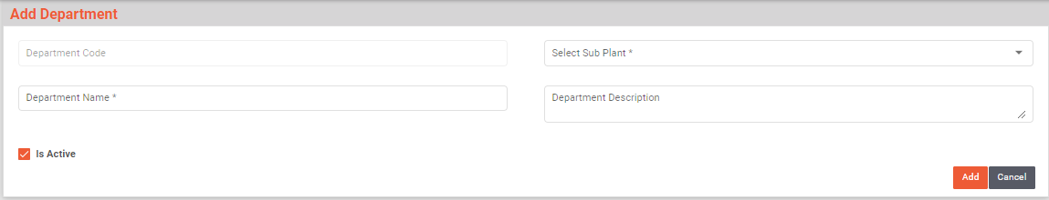

Area Master
This master will contain Area details which will define Area in Departments. With the help of this master will maintain area details.
Data Fields | - Area Code  - Area Name  - Area Description  - Select Sub Plant  - Select Department  - Zone  - Is Active
Process Steps | - System will generate a unique code for Area code.  - Enter Area Name and Area Description.  - Select Sub Plant and Department from dropdown.  - Enter Zone.  - Select Status as Is Active if it is active.  - Save the details in database.
Functions | Add, edit/update and delete Area details as per requirement.
Sample Screen Design | 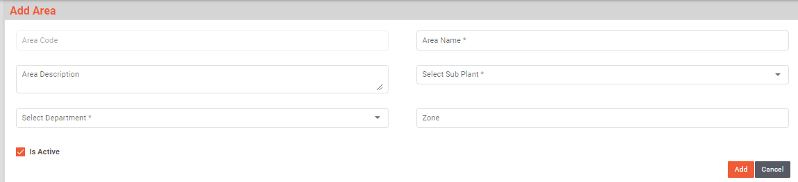

Cubicle Master
Cubicles are generally closed areas under zone and are meant for specific activities. Many times, they may be restricted except few authorized users.
Data Fields | - Cubicle Code  - Select Sub Plant  - Select Department  - Cubicle Description  - Select Area  - Is Active
Process Steps | - Enter Cubicle Code.  - Select Sub Plant and Department from the dropdown  - Enter Cubicle Description.  - Select Area from the dropdown.  - Select Status as Is Active if it is active.  - Save the details in database.
Functions | Add, edit/update, and delete Cubicle details as per requirement.
Sample Screen Design | 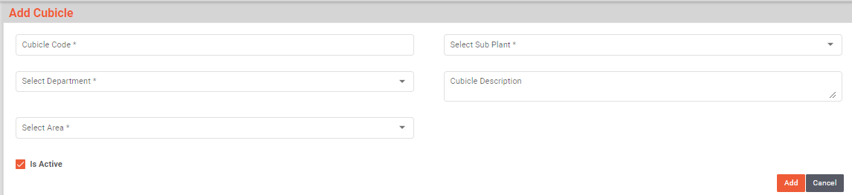

Locations Master
The master module will be used to create/update the Location Master details in database. A barcode will be generated for Locations and will affix on the locations, this will provide a unique identification to each Location. User can take print out of Location barcode as well through this module.
Data Fields | - Location Code  - Storage Location type  - Select Sub Plant  - Location Description  - Select Department  - Select Area  - Zone  - Location Temperature Lower Limit  - Location Temperature Upper Limit  - Temperature Unit  - SLOC Type  - Select Level (example: Level 0 , Level 1, etc.)
Process Steps | - Enter Location Code.  - Enter Location Description.  - Select Storage Location type, Sub Plant, Department, Area, Temperature Unit, and Level from dropdown.  - Enter Zone, Location Temperature Lower Limit, Location Temperature Lower Limit, SLOC Type.  - Select Status as Is Active if it is active.  - Save the details in database.
Functions | Add, edit/update and delete Location details as per requirement.
Sample Screen Design | 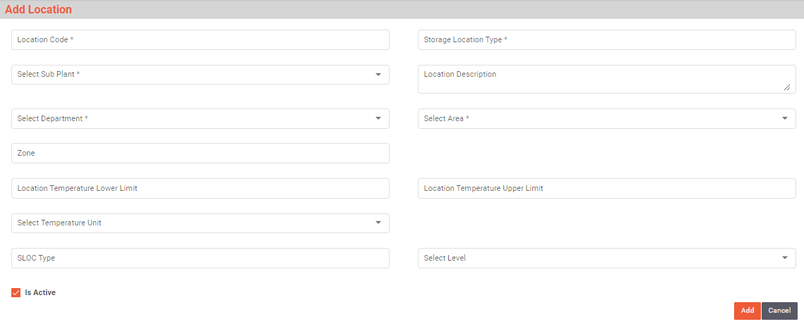

Equipment Master
Apart from raw and production material, warehouse also has other material and equipment that are required to perform various activities. For example, for weighing activity the weight machine or weighing scale is used. Similarly, computers, scanners, machineries etc. are equipment that are used in warehouse activities as catalyst or helper but they themselves are not consumed for production.
Data Fields | - Equipment Code  - Equipment Name  - Equipment Alias  - Select Sub Plant  - Select Department  - Equipment Description  - Select Equipment type  - Select Communication Type  - Vendor Name  - Vendor Document Number  - Date of Procurement  - Maintenance Schedule Days  - Date of Installation  - Support Expire On  - Clean Hold Time  - Is Maintenance Required  - Is Portable  - Is Active
Process Steps | - Enter Equipment Code, Equipment Name, Equipment Alias, and Equipment Description.  - Select Sub Plant, Department, Equipment Type, and Communication Type from the dropdown.  - Enter Vendor Name, Vendor Document Number.  - Select Date of Procurement, Date of Installation, Support Expire On.  - Enter Maintenance Schedule Days, Clean Hold Time.  - Select the checkbox of Is Maintenance Required, Is Portable, and Is Active status as yes if needed.  - Save the details in database
Functions | Add, edit/update, and delete Equipment details as per requirement.
Sample Screen Design | 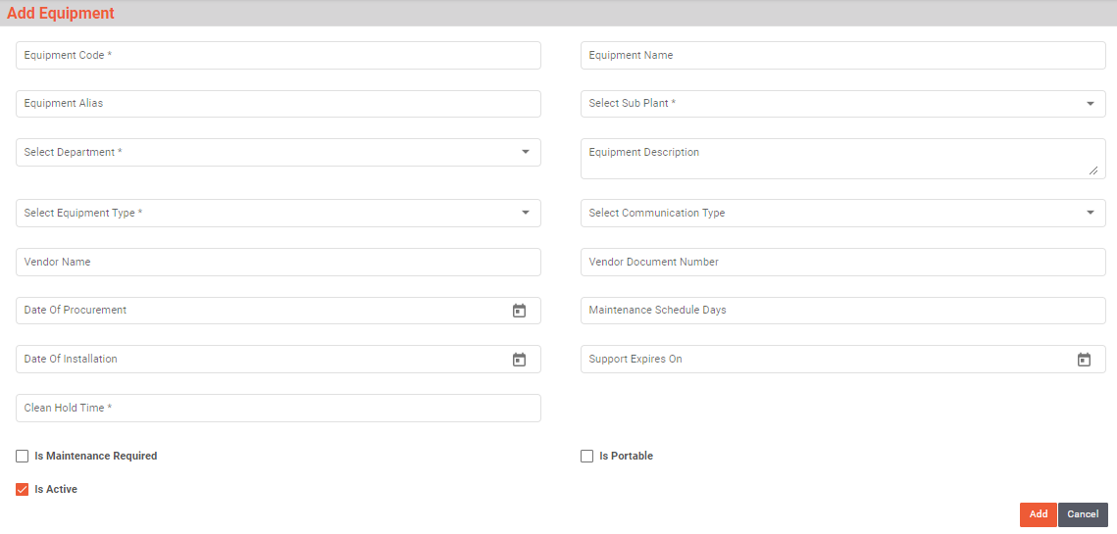

Handling Unit Master
A Handling Unit is a physical unit consisting of packaging materials (load carriers/packing material) and the goods contained on/in it. A handling unit is always a combination of products and packaging materials.
Data Fields | - Handling Unit Code  - Select Sub Plant  - Select Handling Unit Type  - Handling Unit Name  - Handling Unit Description  - Is Active
Process Steps | - Enter Handling Unit Code.  - Select Sub Plant and Handling Unit Type from dropdown.  - Enter Handling Unit Name and Description.  - Select Status as Is Active if it is active.  - Save the details in database.
Functions | Add, edit/update, and delete Handling Unit details as per requirement.
Sample Screen Design | 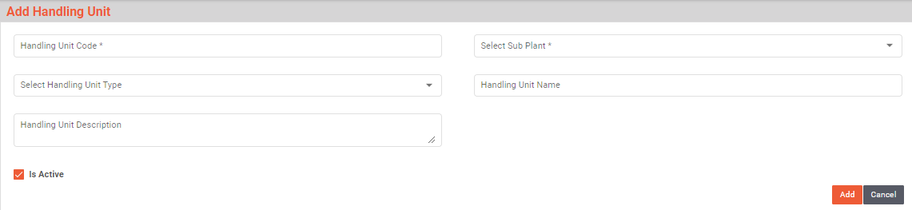

Gates Master
All inward stock movement starts, and all outward movement ends through Gate. Gate pass is generated at the gate which helps controlling vehicle movement inside a plant.
Data Fields | - Name  - Gate Code  - Select Sub Plant  - Gate Description  - Alias Name (if any)  - Is Active
Process Steps | - Enter Gate Name.  - Enter Gate Code.  - Select Sub Plant from dropdown.  - Enter Gate Description.  - Enter Alias Name (if any).  - Select Status as Is Active if it is active.  - Save the details in database.
Functions | Add, edit/update and delete Gate details as per requirement.
Sample Screen Design | 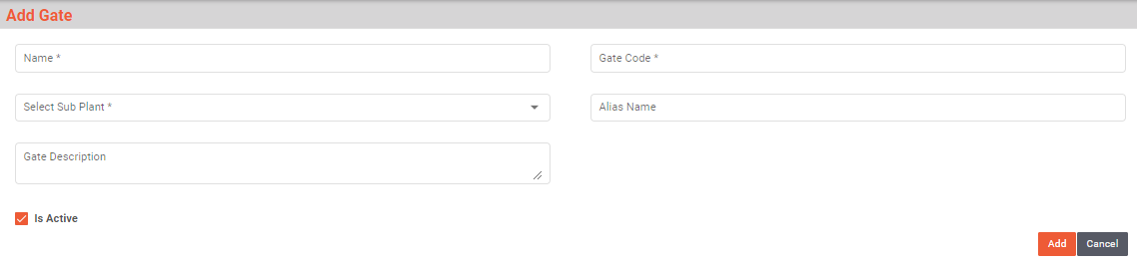

Checklist Type Master
Check List Type master will be used to display the type of checklist while displaying the check point in Check list master and while displaying the check points in the transactions.
Data Fields | - Select Sub Plant  - Select Sub Module  - Checklist Type Name
Process Steps | - Select Sub Plant and Sub Module from Dropdown.  - Enter Checklist Type Name  - Save the details in database.
Functions | Add, edit/update and delete Checklist Type details as per requirement.
Sample Screen Design | 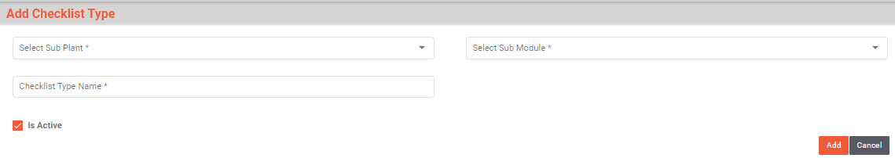

Checklists Master
Inspection Checklist is used in various activities like vehicle inspection, material inspection, cubicle cleaning, line clearance for cubicle etc. Checklist will be created as per the module and will be displayed in that specific module only.
Data Fields | - Checklist Code  - Version  - Checklist Name  - Select Sub Plant  - Select Sub Module  - Checklist Description  - Format Number (SOP No.)  - Select Checklist Type  - Select Mode (Production/Store)  - Is Active
Process Steps | - System will generate a unique code for Checklist Code and Version.  - Enter Checklist Name and Checklist Description.  - Select Sub Plant and Sub Module from dropdown.  - Enter Format Number (SOP No.).  - Select Checklist Type and Mode from the dropdown.  - Select Status as Is Active if it is active.  - Save the details in database.
Functions | Add, edit/update, and delete Inspection Checklist details as per requirement.
Sample Screen Design | 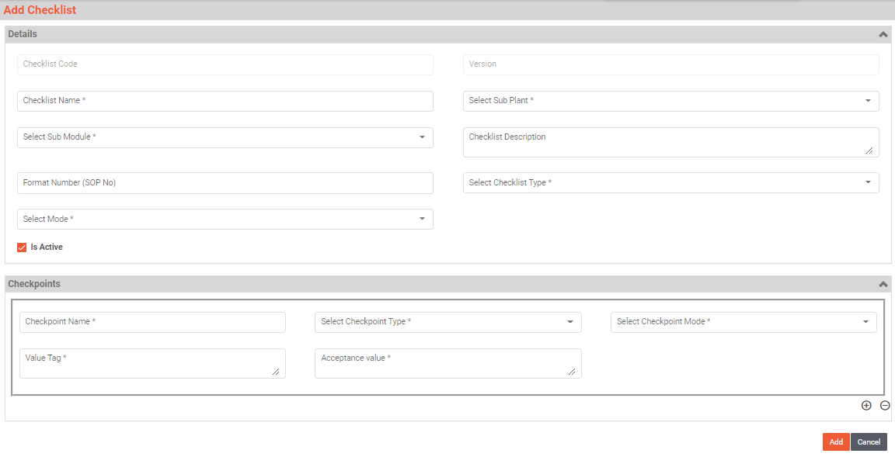

Checkpoints Master
User can add multiple checkpoints against one Checklist.
Data Fields | - Checkpoint Name  - Select Checkpoint Type (Text/ Options/Condition)  - Select Checkpoint Mode (Production/Quality/Store)  - Value Tag  - Acceptance Value
Process Steps | - Enter Checklist Name.  - Select Checkpoint Type from the dropdown.  - Select Checkpoint Mode from the dropdown.  - Enter Value Tag and Acceptance Value.  - Save the details in database.
Functions | Add, edit/update, and delete Checkpoints details as per requirement.
Sample Screen Design | 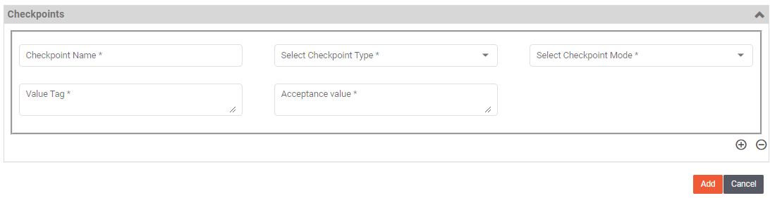

Weighing Balance Master
This master will contain Weighing Machine details. With the help of this master, user will print barcode label for Weighing Machine to provide unique identification to each Weighing Machine at Store and will be able to update or delete the required Weighing Machine details.
Data Fields | - Details:  - Select Balanced Type (Analytical/Normal)  - Weighing Machine Code  - Select Sub Plant  - Select Unit of Measurement  - ID Address  - Port Number  - Model  - Make  - Least Count  - Least Count Digit After Decimal  - Minimum Operating Capacity  - Maximum Operating Capacity  - Stamping Done On  - Stamping Due On  - Capacity  - Eccentricity Standard Weight Value  - Eccentricity Standard Max Value  - Eccentricity Standard Weight Value  - Eccentricity Instruction  - Linearity Standard Weight Value (Weight 1)  - Linearity Acceptance Min Value (Weight 1)  - Linearity Acceptance Max Value (Weight 1)  - Linearity Standard Weight Value (Weight 2)  - Linearity Acceptance Min Value (Weight 2)  - Linearity Acceptance Max Value (Weight 2)  - Linearity Standard Weight Value (Weight 3)  - Linearity Acceptance Min Value (Weight 3)  - Linearity Acceptance Max Value (Weight 3)  - Linearity Standard Weight Value (Weight 4)  - Linearity Acceptance Min Value (Weight 4)  - Linearity Acceptance Max Value (Weight 4)  - Linearity Standard Weight Value (Weight 5)  - Linearity Acceptance Min Value (Weight 5)  - Linearity Acceptance Max Value (Weight 5)  - Linearity Instruction  - Repeatable Standard Weight Value  - Repeatable Acceptance Min Value  - Repeatable Acceptance Min Value  - Repeatable Instruction  - Uncertainty Acceptance Value(NMT%): fixed 0.001  - Uncertainty Instruction  - Select Frequency  - Reference SOP No  - Format No  - Version  - Is active  - Balance Calibration Test Configuration:  - Select Frequency  - Test Type: Eccentricity Test, Linearity Test, Repeatability Test, Uncertainty Test  - Balance Verification:  - Select Frequency  - Calibration Level  - Calibration Criteria  - Standard Weight  - Minimum Value  - Maximum value
Process Steps | - Details:  - Select Balanced Type (Analytical/Normal), Select Sub Plant, Select Unit of Measurement from dropdown.  - Enter Weighing Machine Code, ID Address, Port Number, Model, Make, Least Count, Minimum Operating Capacity, Maximum Operating Capacity.  - Select Stamping Done On, Stamping Due On.  - Enter Capacity, Eccentricity Standard Weight Value, Eccentricity Standard Max Value, Eccentricity Standard Weight Value, and Eccentricity Instruction.  - Enter Linearity Standard Weight Value, Linearity Acceptance Min Value, Linearity Acceptance Max Value, and Linearity Instruction.  Note: (User can enter the Linearity values for weight 1 to weight 5)  - Enter Repeatable Standard Weight Value, Repeatable Acceptance Min Value, Repeatable Acceptance Max Value, and Repeatable Instruction.  - Select Frequency from dropdown.  - Enter Reference SOP No, Format No, Version.  - Select Is active if it is active.  Note: Uncertainty Acceptance Value(NMT%) is fixed as 0.001  - Balance Calibration Test Configuration:  - Select Frequency from dropdown.  - Select Test Type: Eccentricity Test, Linearity Test, Repeatability Test, Uncertainty Test.  - Click on Add button.  - Balance Verification::  - Select Frequency from dropdown.  - Enter Calibration Level, Calibration Criteria, Standard Weight, Minimum Value, Maximum value  - Click on Add button to save the details in the database.
Functions | Add, edit/update, and delete Weighing Machine details as per requirement.
Sample Screen Design | 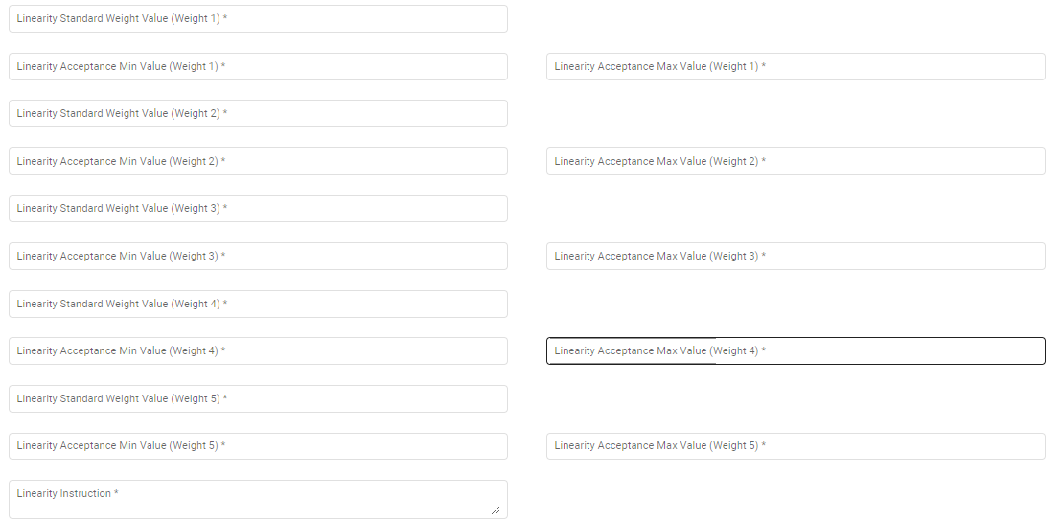  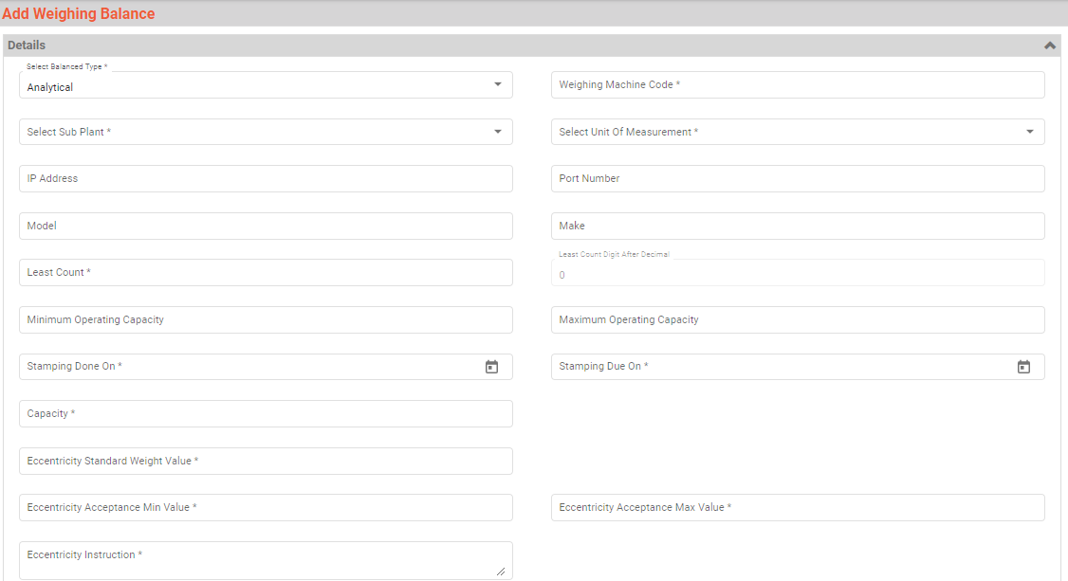  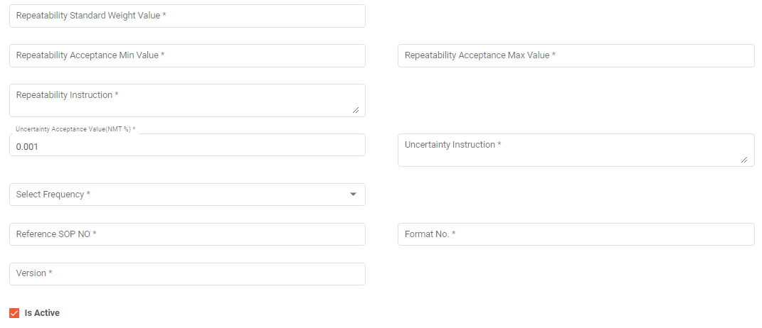  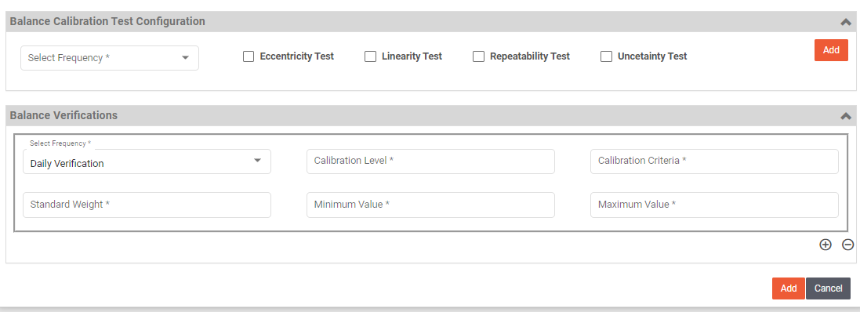

Standard Weight Boxes Master
This master will contain Standard Weight Box details which are used while weighing calibration. With the help of this master, in this master Standard Weight Box ID will be maintain as unique id.
Data Fields | - Standard Weight Box ID  - Select Sub Plant  - Select Department  - Select Area  - Standard Weight Box Description  - Is Status
Process Steps | - Enter Standard Weight Box ID.  - Select Sub Plant, Department, and Area from the dropdown.  - Enter Standard Weight Box Description.  - Select Status as Is Active if it is active.  - Save the details in database.
Functions | - Add, edit/update, and delete Standard Weight Box details as per requirement.
Sample Screen Design | 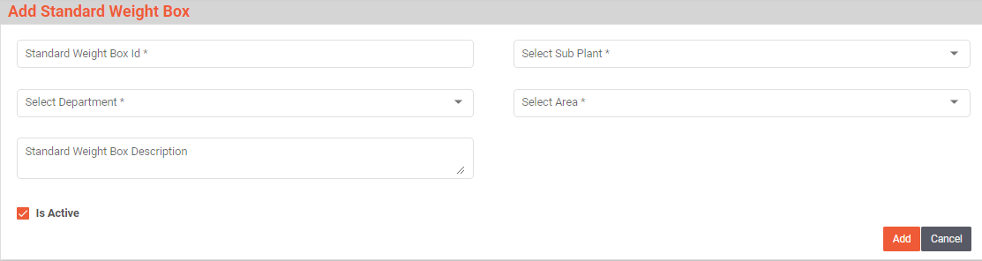

Standard Weight Master
This master will contain Standard Weight details which are used while weighing calibration. With the help of this master, in this master Standard weight ID will be maintain as unique id.
Data Fields | - Standard Weight ID  - Select Sub Plant  - Select Department  - Standard Weight Description  - Select Area  - Capacity  - Select Unit of Measurement  - Select Standard Weight Box  - Stamping Done On  - Stamping Due On  - Is Status
Process Steps | - Enter Standard Weight ID.  - Select Sub Plant, Department from the dropdown.  - Enter Standard Weight Description, Capacity.  - Select Area, Unit of Measurement, and Standard Weight Box from the dropdown.  - Select Stamping Done On and Stamping Due On dates.  - Select Status as Is Active if it is active.  - Save the details in database.
Functions | Add, edit/update, and delete Standard Weight details as per requirement.
Sample Screen Design | 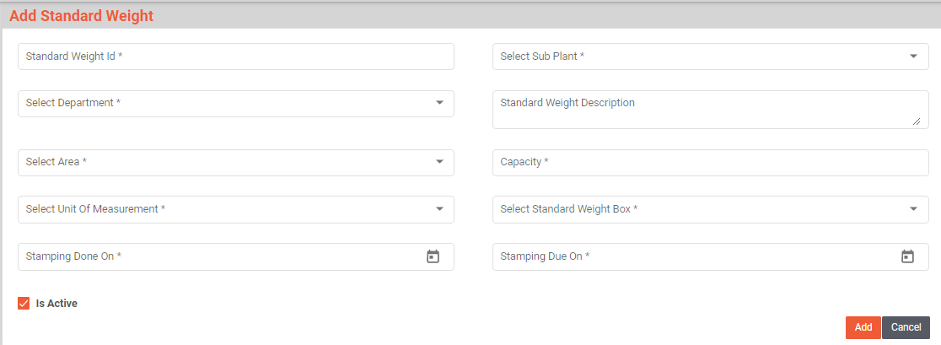

Unit of Measurements Master
Unit of Measure (UoM) is a quantity used as a standard of measurement for the inventory. PMMS defines all standard units used in inventory and the conversion rates from one to another.
Data Fields | - UoM Name  - Select UoM Type  - UoM Description  - UOM  - Is Active
Process Steps | - Enter UoM Name.  - Select UoM Type from dropdown.  - Enter UoM Description and UoM.  - Select Status as Is Active if it is active.  - Save the details in database.
Functions | Add, edit/update, and delete UoM details as per requirement.
Sample Screen Design | 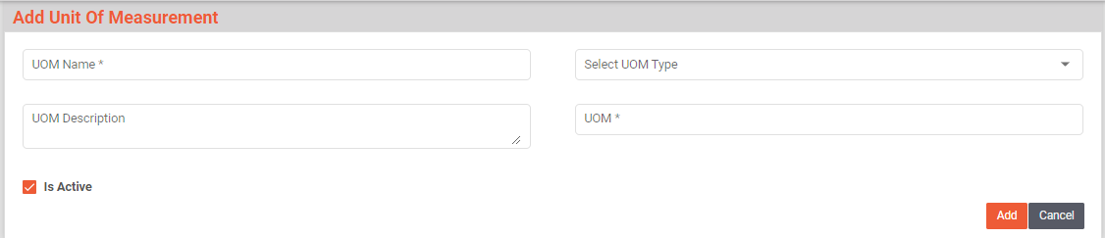

Devices Master
This master will store Devices details, through system can have details of all the devise information as Mobile device, Printer and tablets and maintain the connection parameters. Through which the devices will be accessible in network.
Data Fields | - Device ID  - Select Sub Plant  - Select Device Type (Mobile/Printer/Tablet)  - Select Mode (Production/Quality/Store)  - IP Address  - Port  - Make  - Model  - Serial Number  - Select Department  - Select Area  - Select Cubicle  - Is Active
Process Steps | - Enter Device ID, it can be alpha numeric.  - Select Sub Plant from dropdown.  - Select Device Type (Mobile/Printer/Tablet) from dropdown.  - Select Mode (Production/Quality/Store) from dropdown.  - Enter other details such as IP Address, Port, Make, Model, and Serial Number.  - Select Department, Area, and Cubicle from dropdown.  - Select Status as Is Active if it is active.  - Save the details in database.
Functions | Add, edit/update, and delete Devices details as per requirement.
Sample Screen Design | 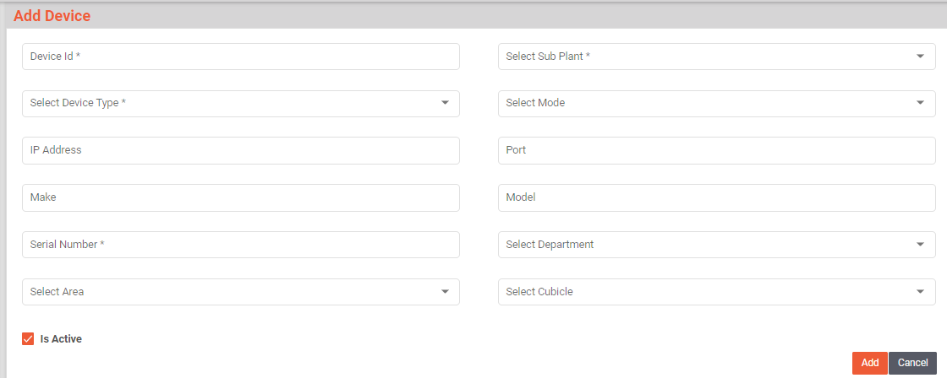

Activity Master
This master will contain Activity details which are used while weighing calibration. With the help of this master, in this master Activity Code will be maintain as unique code for each activity.
Data Fields | - Activity Name  - Activity Code  - Activity Description  - Select Module Name  - Select Sub Module Name  - Is Active
Process Steps | - Enter Activity Name, Activity Code, and Activity Description.  - Select Module Name, Sub Module Name.  - Select Status as Is Active if it is active.  - Save the details in database.
Functions | View details of the Activity master.
Sample Screen Design | 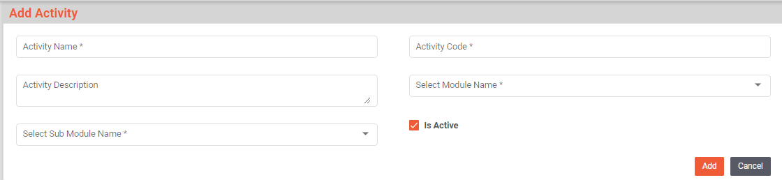

Inward

Gate Entry
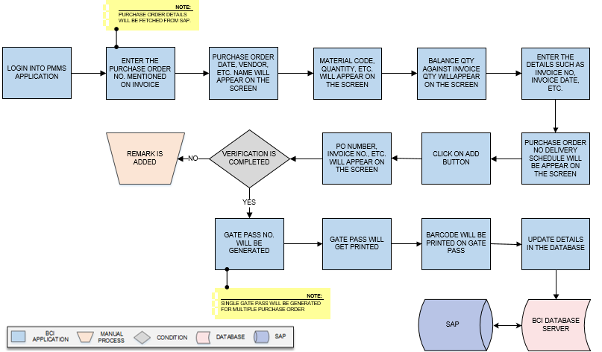
Activities
Module Description | Gate Pass activities controls and manage the external vehicle movement inside the plant for unloading the material.

Pre-Conditions | - Purchase Order details needs to be imported from SAP.  - Checklist should available in Checklist master.

Process Steps | - Security Person will login into PMMS Application.  - Enter the Purchase Order No. mentioned on Invoice in Gate Entry module.  *Purchase Order details will be fetched from SAP.  - Details such as Purchase Order Date, Vendor Name, and Vendor Code will appear on the screen.  - A grid format of Material details such as Material Code, Material Description, Quantity, Manufacturer Code, Manufacturer Name, and UOM will appear on the screen.  - User will enter Invoice Quantity.  - Balance quantity against invoice quantity will appear on the screen.  - Enter the remaining details such as Invoice No, Invoice Date, Transporter Name, LR No, LR Date, Driver Name, Vehicle No, Vendor Batch No, Delivery Note, Bill of Landing.  - Purchase Order No Delivery Schedule will be appear on the screen from the Invoice date.  - Click on Add button to save the details.  - A grid format of Purchase Order details such as PO Number, Vendor Name, Invoice No., Invoice Date, LR No., LR Date, Vendor Batch No., and Remove will appear on the screen.  - If the verification is not passed.  - Remark is added.  - Inspection will be completed.  - Gate Pass No. will be generated.  Note: i. Single Gate Pass will be generated for multiple Purchase Order.  - Gate Pass will get printed.  - Barcode will be printed on Gate pass.  - Update the details in the database.

Post-Conditions | - Gate Pass barcode should be available at the unloading bay.

Validations | - An alert should be displayed in case duplicate/ invalid Purchase Order No is entered.  - An alert should be displayed in case duplicate/ invalid Invoice No is entered.  - An alert should be displayed in case Purchase Order details are not fetched from SAP.

Sample Screen Design | 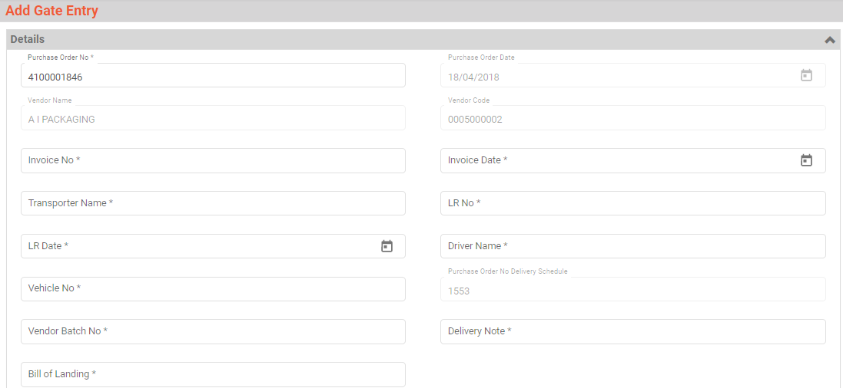

Vehicle Inspection
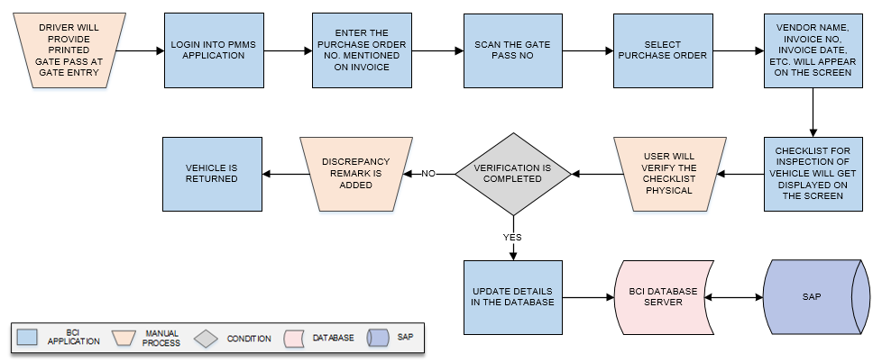
Activities
Module Description | Before unloading material from the vehicle, vehicle will be inspected against the defined checklist.

Pre-Conditions | - Printed Gate Pass should be printed given at the Gate entry.  - Checklist should available in Checklist master.

Process Steps | - Driver will provide printed Gate Pass at the Gate entry.  - User will login in PMMS application.  - Scan the Gate Pass No.  - Select Purchase Order.  - Details such as Vendor Name, Invoice No, Invoice Date, LR No, LR Date, Driver Name, Vehicle No, Purchase Order No Delivery Schedule, Delivery Note, Bill of Landing, Vendor Batch No, and Vendor Code will appear on the screen.  - Checklist for inspection of vehicle will appear on the screen.  - User will verify the checklist physical.  - If the verification is not completed:  - Discrepancy remark is added.  - Vehicle is returned.  - Inspection will be completed.  - Update the details in the database.

Post-Conditions | - Vehicle inspection will be completed.

Validations | - An alert should be displayed in case invalid Gate Pass is scanned.  - An alert should be displayed in case duplicate/ invalid Purchase Order is selected.  - An alert should be displayed in case of invalid activity.

Sample Screen Design | 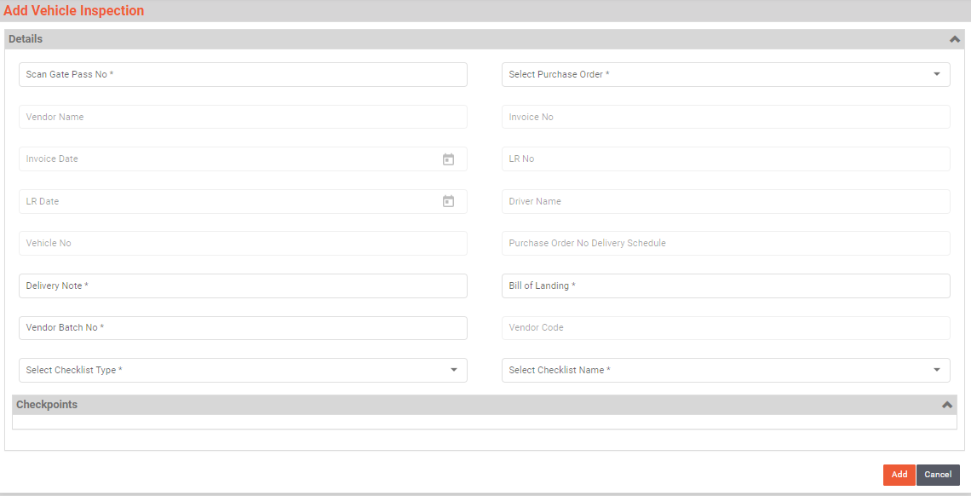

Material Inspection
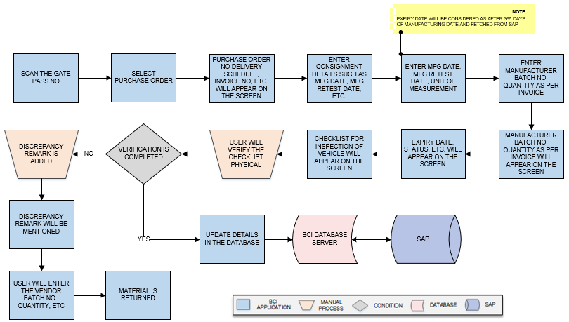
Activities
Module Description | In this module material is inspected after the material has arrived, mostly from outside plant (from Vendor, other plants etc.)

Pre-Conditions | - Gate Pass should be available for scanning.  - Vehicle Inspection should be completed.

Process Steps | - Scan the Gate Pass No.  - Select Purchase Order from dropdown.  - Details such as Purchase Order No Delivery Schedule, Invoice No, Invoice Date, LR No, LR Date, Driver Name, Vehicle No, Vendor Name, Delivery Note, Bill of Landing, Vendor Batch No, and Vendor Code will appear on the screen.  - User will select Consignment details such as Manufacturing Date and Manufacturing Retest Date, Unit of Measurement.  *Expiry date will be considered as after 365 days of manufacturing date and fetched from SAP.  - Enter Manufacturer Batch No, Quantity as per Invoice in Consignment Details.  - Expiry date, Remaining days left for Retest, Status, Remaining days left for Expiry, will appear on the screen.  - Checklist for inspection of vehicle will appear on the screen.  - User will verify the checklist physical.  - If the verification is not completed:  - Discrepancy remark will be mentioned against damaged material.  - User will enter the Vendor Batch No., Quantity, Container No, Unit of Measurement, and Remark.  - Material is returned.  - Inspection will be completed.  - Update the details in database.

Post-Conditions | - Material inspection will be completed.

Validations | - An alert should be displayed in case invalid Gate Pass is scanned.  - An alert should be displayed in case duplicate/ invalid Purchase Order is selected.  - An alert should be displayed in case of invalid activity.

Sample Screen Design | 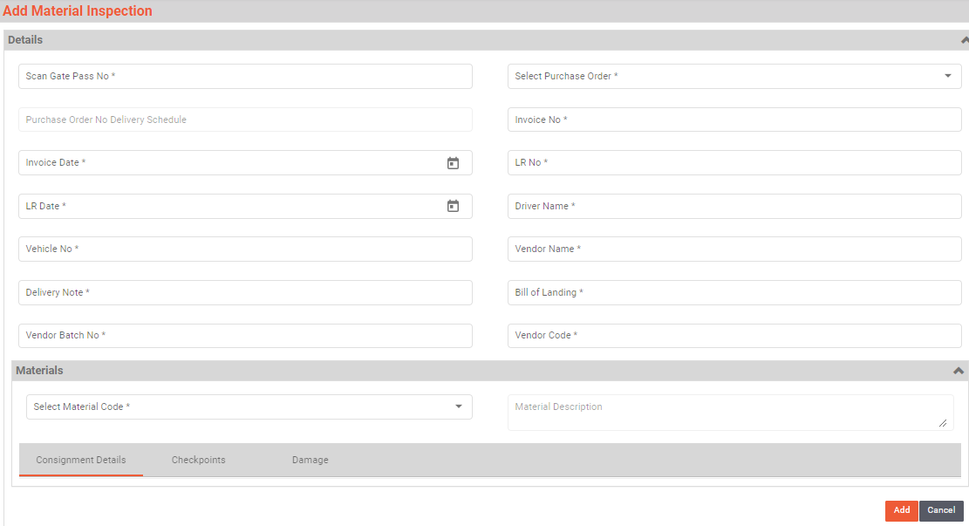

Weight Capture
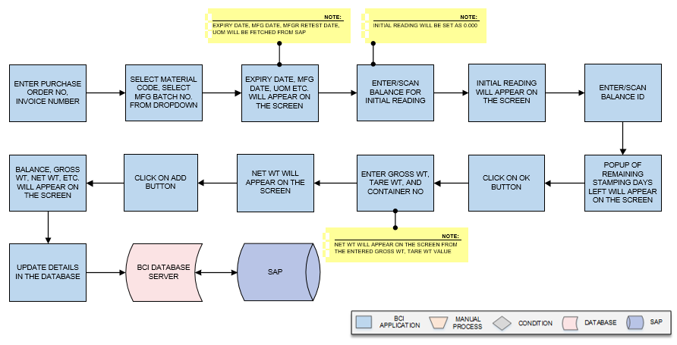
Activities
Module Description | In this module the Weight details of Inspected materials are maintained.

Pre-Conditions | - Material Inspection should be completed.  - Weighing Balance master should be available.

Process Steps | - Enter Purchase Order No, Invoice Number.  - Select Material Code, Select Mfg Batch No. from dropdown.  - Expiry Date, Mfg Date, Mfgr Retest Date, UOM will appear on the screen.  * Expiry Date, Mfg Date, Mfgr Retest Date, UOM will be fetched from SAP.  - Enter/Scan Balance for Initial reading.  * Initial reading will be set as 0.000.  - Initial reading will appear on the screen.  - Enter/Scan balance Id.  - Popup of Remaining Stamping Days Left will appear on the screen.  - Click on OK button.  - Enter Gross Wt, Tare Wt, and Container No.  *Net Wt will appear on the screen from the entered Gross Wt, Tare Wt value.  - Net wt will appear on the screen.  - Click on Add button.  - Grid of balances such as Scan Balance, Gross wt, Net wt, Tare wt, UOM, Container No., and action will appear on the screen.

Post-Conditions | - Weight Capture details get in displayed.

Validations | - An alert should be displayed in case duplicate/invalid Purchase Order is entered.  - An alert should be displayed in case duplicate/invalid Invoice Number is selected.  - An alert should be displayed in case of Initial reading will not set to zero.  - An alert should be displayed in case of invalid activity.

Sample Screen Design | 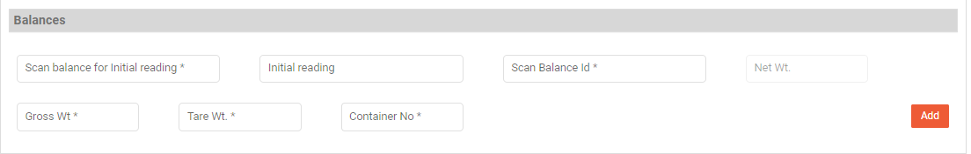  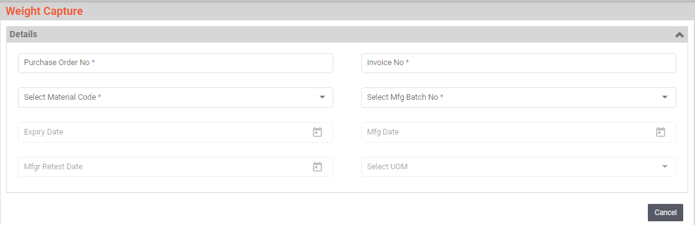

GRN Posting
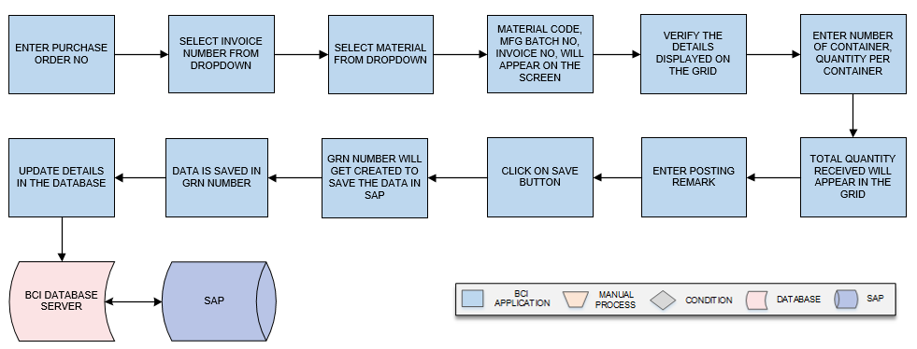
Activities
Module Description | In this module the inspected data of Material, Weight Capture details are submitted to SAP.

Pre-Conditions | - Weighing Balance master should be available.

Process Steps | - Enter Purchase Order No.  - Select Invoice Number from dropdown.  - Select Material from dropdown.  - A grid format of Grid format of Material Code, Material Description, Manufacturing Batch Number, Invoice Number, Consignment Quantity, Is Damage, Number of Containers, Quantity per Container, Total Quantity Received, Posting Remark, Action will appear on the screen.  - Verify the details displayed on the grid.  - Enter Number of Container, Quantity per Container.  - Total Quantity Received will appear in the grid.  - Enter Posting Remark.  - Click on Save button.  - GRN number will get created to save the data in SAP.  - Data is saved in GRN number.

Post-Conditions | - Material and Weight capture details will get maintained in SAP by GRN number.

Validations | - An alert should be displayed in case duplicate/ invalid Purchase Order is selected.  - An alert should be displayed in case duplicate/ invalid Invoice Number is selected.  - An alert should be displayed in case of invalid activity.  - An alert should be displayed in case of GRN number is not created.

Sample Screen Design | 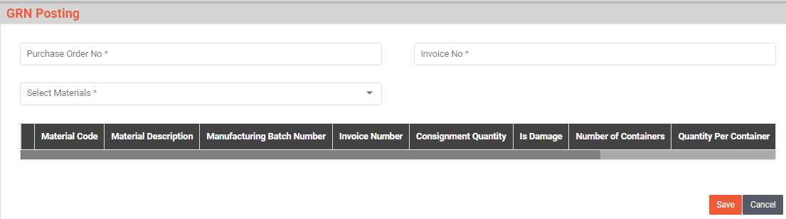

Material Label Printing
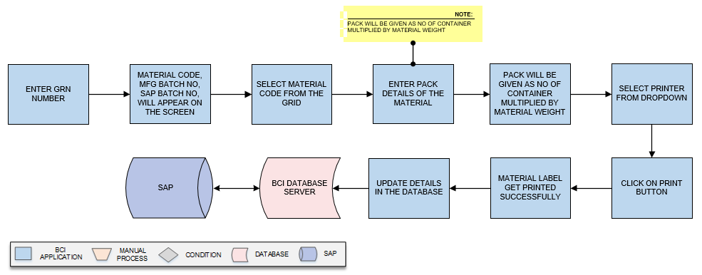
Activities
Module Description | The Module will be used to print material label for each container.

Pre-Conditions | - Material data should be saved in GRN number.  - Material Inspection needs to be completed.

Process Steps | - Enter GRN number.  - A grid format of Grid format of Material Code, Material Description, Manufacturing Batch Number, SAP Batch Number, Manufacturing Date, Expiry Date, Pack details, No of Containers will appear on the screen.  - Select Material Code from the grid.  - Enter Pack Details of the material.  *Pack will be given as no of container multiplied by material weight.  - Select printer from dropdown.  - Click on Print button.  - Material label get printed successfully.  - Data is saved in database.

Post-Conditions | - Material Label get printed.

Validations | - An alert should be displayed in case duplicate/ invalid GRN number is entered.  - An alert should be displayed in case duplicate/ invalid Pack Details are entered.

Sample Screen Design | 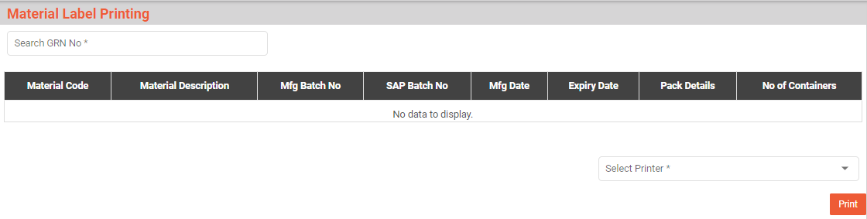

Palletization
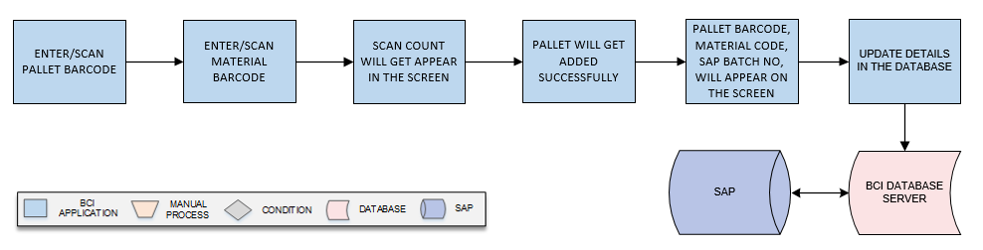
Activities
Module Description | This module will be used to map pallet and material containers placed on pallet.

Pre-Conditions | - Material weights are captured and printed labels are applied on each container.  - Pallet should have barcode.

Process Steps | - Enter/Scan Pallet Barcode.  - Enter/Scan Material Barcode.  - Scan count will get appear in the screen.  - Pallet will get added successfully.  - A grid format of Pallet details such as Pallet Barcode, Material Code, Material Description, SAP Batch No, Count, and Action will appear on the screen.  - Data is saved in database.

Post-Conditions | - Pallet details are saved in database.  - Pallets are moved for Put away in warehouse.

Validations | - An alert should be displayed in case duplicate/ invalid Pallet Barcode is entered.  - An alert should be displayed in case duplicate/ invalid Material Barcode is entered.

Sample Screen Design | 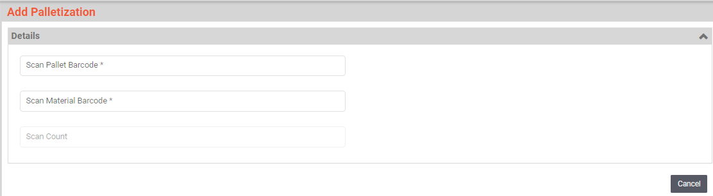

Put Away
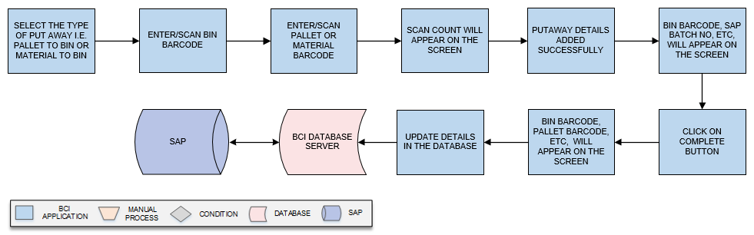
Activities
Module Description | This module will be used to map Pallets to Bins and Material to Bins.

Pre-Conditions | - Material weights should be captured and labels are applied on each container.  - Palletization should be completed.

Process Steps | - Select the type of Put Away i.e. Pallet to Bin or Material to Bin.  - Enter/Scan Bin Barcode.  - Enter/Scan Pallet or Material Barcode.  - Scan count will appear on the screen.  - Putaway details added successfully.  - A grid format of Bin Barcode, Material Description, SAP Batch No, and Container No will appear on the screen.  - Click on Complete Button.  - A grid format of Bin Barcode, Pallet Barcode, Material Code, Material Description, SAP Batch No, Count, and Action will appear on the screen.  - Data is saved in database.

Post-Conditions | - Pallet or Material Put Away is completed.

Validations | - An alert should be displayed in case duplicate/ invalid Bin Barcode is entered.  - An alert should be displayed in case duplicate/ invalid Pallet Barcode is entered.  - An alert should be displayed in case duplicate/ invalid Material Barcode is entered.

Sample Screen Design | 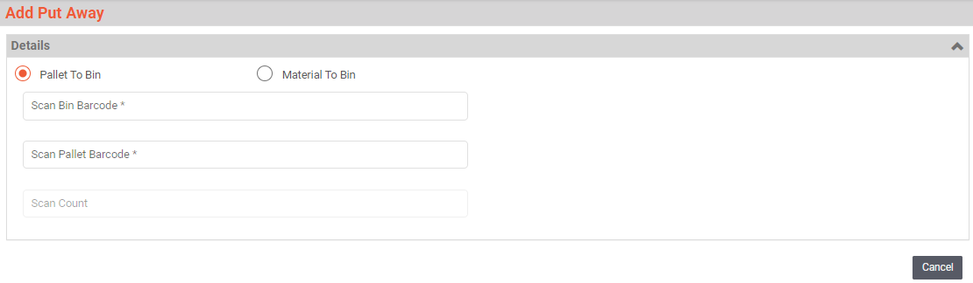

Bin To Bin Transfer
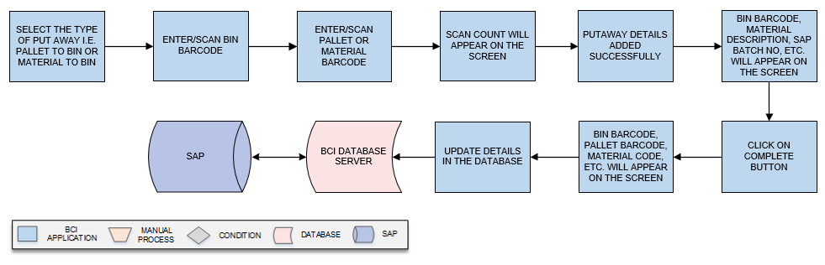

Activities
Module Description | This module will be used to transfer material or pallet from one bin to other.

Pre-Conditions | - Material weights should be captured and labels are applied on each container.  - Palletization should be completed.  - Empty

Process Steps | - Select the type of Put Away i.e. Pallet to Bin or Material to Bin.  - Enter/Scan Bin Barcode.  - Enter/Scan Pallet or Material Barcode.  - Scan count will appear on the screen.  - Putaway details added successfully.  - A grid format of Bin Barcode, Material Description, SAP Batch No, and Container No will appear on the screen.  - Click on Complete Button.  - A grid format of Bin Barcode, Pallet Barcode, Material Code, Material Description, SAP Batch No, Count, and Action will appear on the screen.  - Data is saved in database.

Post-Conditions | - Material are transferred from one bin to other bin.

Validations | - An alert should be displayed in case duplicate/ invalid Bin Barcode is entered.  - An alert should be displayed in case duplicate/ invalid Pallet Barcode is entered.  - An alert should be displayed in case duplicate/ invalid Material Barcode is entered.  - Allocated material can only be transferred.

Sample Screen Design | 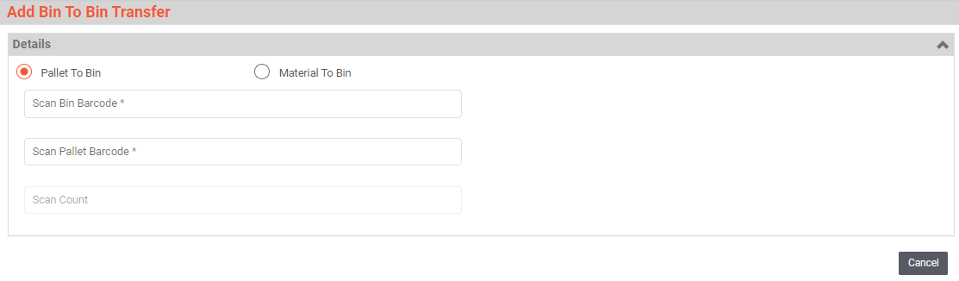

Sampling

Cubicle Assignment

Activities
Module Description | This module will be used to assign cubicle for sampling of Raw material and Packing material against the Inspection Lot/A.R.No.

Pre-Conditions | - Inspection Lot/A.R.No. details needs to be imported from SAP.

Process Steps

Post-Conditions | - Further process of sampling can be done like Line clearance or Picking  - For packing material line clearance will not be done.

Validations | Change Tone:  - While creating group system will validate process order release data is imported from SAP.  - While assigning cubicle system will validate the material is not already assigned to other cubicle.  - System will allow cubicle to be assigned to multiple material and cubicle will be activated for sampling particular Inspection Lot/A.R.No. after confirming in Line clearance.

Cubicle Cleaning

Activities
Module Description | This module will be used for Cubicle cleaning process.to log the Area usage and cleaning digitally in system.

Pre-Conditions | - Cubicle status should be unclean in system.

Process Steps

Post-Conditions | - Line clearance of cubicle against process order

Validations | - Sequence of cleaning will be followed as Cleaning Start, Cleaning Stop and Verification  - Unclean cubicle can only start cleaning.  - If cleaning is not completed at the end of the day by user, then higher authorized user needs to scan and approve to start cleaning for next day.

Equipment Cleaning

Activities
Module Description | This module will be used for Equipment cleaning process.to log the Area usage and cleaning digitally in system.

Pre-Conditions | - Equipment status should be unclean in system.

Process Steps

Post-Conditions | - Line clearance of cubicle against process order

Validations | - Sequence of cleaning will be followed as Cleaning Start, Cleaning Stop and Verification  - Unclean cubicle can only start cleaning.

Dispensing

Cubicle Assignment
Activities
Module Description | This module will be used to assign cubicle for dispensing of Raw material and Packing material against the process order.

Pre-Conditions | - Process Order details should be be imported from SAP.

Process Steps | - Cubicle Assignment  - User will select the Process Order No/Reservation No. from the drop down list.  *Process Order No for which batch determination is done in SAP.  - Enter Product Code.  - Select Batch No. from the dropdown.  - Click on “Add” button on the screen for adding multiple process order of same product.  - A grid format of Line Item No, Cubicle Id, Material Code, Description, SAP Batch No, Quantity, UOM, Expiry Date, Retest Date, A R No will appear on the screen.  - Click on Line Item No. from grid that user want to assign.  - Select Cubicle ID.  - Status will appear on the screen.  - Click on Assign button.  - The cubicle will be assigned successfully.  - Group code will be generated against Process Order/Reservation No.  - A grid format of Group Code, Process Order No/Reservation No, Group Status, and Action will appear on the screen.  - De-Assign  - User will select the material from the list and click on De-Assign button.  *If user is not able to change the cubicle or want to remove the assignment of the cubicle to specific material.  - System will free the cubicle and material and will be available for assignment again.

Post-Conditions | - Cubicle assignment is completed.  - Cubicle will be available for cleaning.

Validations | - An alert should be displayed in case duplicate/ invalid Process Order is selected.  - An alert should be displayed in case of invalid activity.

Sample Screen Design | 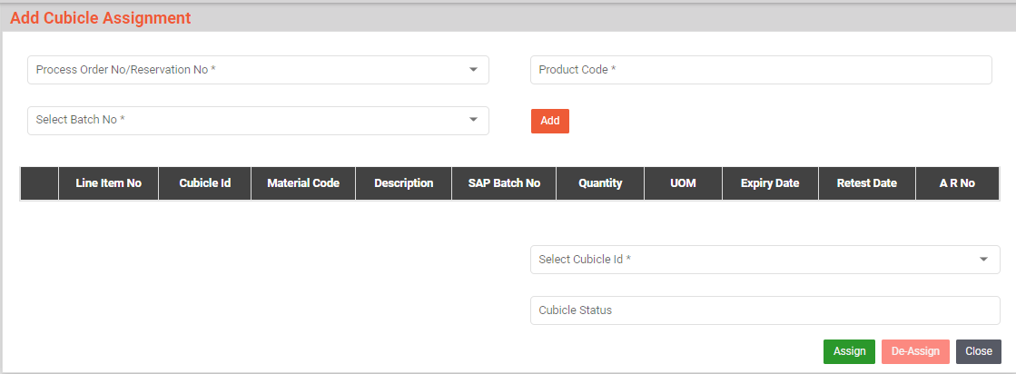

Cubicle Cleaning
Activities
Module Description | This module will be used for Cubicle cleaning process to log the Area usage and cleaning digitally in system.

Pre-Conditions | - Cubicle status should be unclean in system.  - Cubicle assignment should be completed.

Process Steps | - Cleaning  - Scan the Cubicle Barcode.  - Area and Cubicle Status will appear on the screen.  - Select Type from dropdown.  - Cubicle cleaning will be started successfully.  - A grid format of Action, Status, Time, Action Taken By, Checkpoints will appear on the screen.  - Click on OK option for the clean process in the Checkpoints.  - If user select NOT OK then system will not allow verification and allow Re-Cleaning.  - Add Remark if needed.  - Enter user name in Done By section.  - Click on Clean button.  - Verification  - Authorized user Scan the Cubicle Barcode.  - Area, Cubicle Status, Done By will appear on screen.  - Select Type from dropdown.  - A grid format of Action, Status, Time, Action Taken By, Checkpoints will appear on the screen.  - Select the OK option from the Checkpoint.  - Click on Approve button.  - If user select NOT OK then system will not allow verification and allow Re-Cleaning.  - Add Remark if needed.  - Enter Approval/Reject Description.  - Click on Reject Button.

Post-Conditions | - Line clearance of cubicle against process order is completed.

Validations | - An alert should be displayed in case duplicate/ invalid Cubicle Barcode is selected.  - Sequence of cleaning will be followed as Cleaning Start, Cleaning Stop and Verification.  - Unclean cubicle can only start cleaning.  - If cleaning is not completed at the end of the day by user, then higher authorized user needs to scan and approve to start cleaning for next day.

Sample Screen Design | 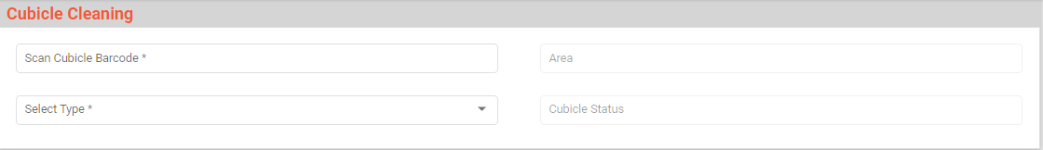

Equipment Cleaning
Activities
Module Description | This module will be used for Equipment cleaning process to log the Area usage and cleaning digitally in system.

Pre-Conditions | - Equipment status should be unclean in system.

Process Steps | - Assign process  While starting the assignment of Equipment user will scan the cubical room and the equipment  Process Steps  - User will scan Cubical Barcode in Equipment Cleaning in which equipment is placed.  - Group code, Product Code, Description and Batch No will appear on the screen.  - User will scan Equipment Barcode which is applied on Equipment.  *Many equipment can be selected as per cubical requirement.  - Status will appear on screen.  *Only cleaned equipment will be assigned.  - The Equipment code, name and Type gets displayed in table grid format.  - Select the check box of Equipment code to select the assigned equipment.  *Only portable device can be assigned and de-assigned by user.  - Then click on Assign button, the equipment gets assigned to that cubical.  - De-Assign Process  - Authorized user Scan Cubical Barcode in which equipment is placed in Equipment Cleaning.  - The Group Code, Product code, Description, and Batch No will appear on the screen.  - User will scan Equipment barcode which is applied on Equipment.  *Many equipment can be selected as per cubical requirement.  - Status will appear on the screen.  *Only cleaned equipment will be assigned.  - The Equipment Code, Name, and Type will appear on the screen.  - Select the check box of Equipment code to select the assigned equipment.  *Only portable device can be assigned and de-assigned by user.  - Then click on the “De-Assign” button, and the equipment goes to previous stage.

Post-Conditions | - Equipment clearance of cubicle against process order is completed.

Validations | - An alert should be displayed in case duplicate/ invalid Cubicle Barcode is selected.  - Sequence of cleaning will be followed as Cleaning Start, Cleaning Stop, and Verification.  - Unclean cubicle can only start cleaning.

Sample Screen Design | 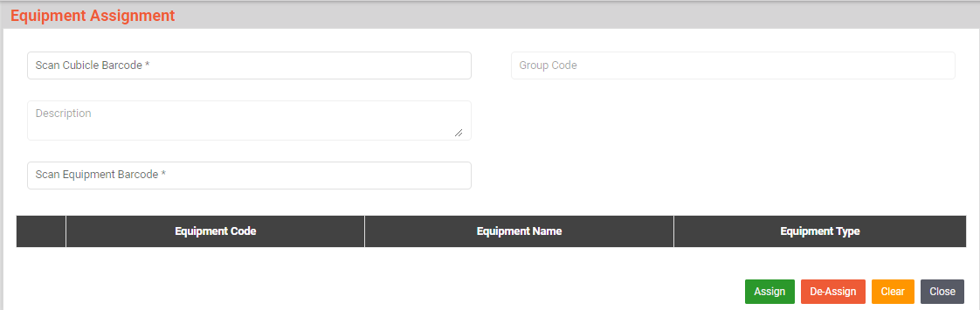

Line Clearance
Activities
Module Description | This module will be used for Line Clearance of cubicle against process order.

Pre-Conditions | - Cubicle Cleaning should be completed.

Process Steps | Line Clearance will be done in 3 steps.  - Line Clearance  User will perform line clearance check list in PMMS device application  - User will scan the Cubicle Barcode.  - The Area Barcode and Cubical Status will appear on the screen.  - Select the Group from the dropdown list.  - Checkpoints for Line Clearance, Cleanliness of Cubical and Cleanliness 2 for equipment will appear in table grids format.  - User will click on OK.  - If user select NOT OK then system will not allow verification.  - Add Remark if needed.  - Selection of checkpoints will be allowed for pre stage.  - User will click on Save button.  - Line clearance will be completed here.  - Approve by Warehouse person  - Authorized Scan the Cubicle Barcode.  - The Area Barcode and Cubical Status will appear on screen.  - Select the Group from the dropdown list.  - Action, Status, Time, and Action taken by will appear on the screen in the table grid format.  - Checkpoints for Line Clearance, Cleanliness of Cubical and Cleanliness 2 for equipment will appear in table grid format.  - User will click on OK.  - If user select NOT OK then system will not allow verification.  - Add Remark if needed  - Click on Approve button to accept the work done.  - The Successfully Line clearance approved message pop up.  - System will store date and time as Verified By and login user id.  - If anything is found non satisfactory then user will click on Reject button.  - Verification by QA  - Authorized Scan the Cubicle Barcode.  - The Area Barcode and Cubical Status will appear on the screen..  - Select the group from the dropdown list.  - The table with Action, Status, Time, and Action taken by data gets displayed in the table grid.  * The start person and approved person details gets displayed.  - System will display check list with results selected while line clearance  - And also display check list below  - Checkpoints for Line Clearance, Cleanliness of Cubical and Cleanliness 2 for equipment gets displayed in table grids.  - User will check as “OK” or “Not OK”, if user select “No” then user will enter remark in next column.  - Then click on “Verified” button to accept the work done.  - The Line clearance approved successfully message pop up.  - If anything is found non satisfactory then user will click on “Reject” button.  *On rejection it goes back to the initiator for rework.

Post-Conditions | - Picking of material will be done.

Validations | - An alert should be displayed in case duplicate/ invalid Cubicle Barcode is selected.  - Scanning of cubicle barcode will be allowed for which Cubicle cleaning completed for Line clearance.  - Once line clearance is done then only verification can be performed.  - If activity is not accepted by checked by or verified by then again Re-line- clearance needs to be performed.

Sample Screen Design | 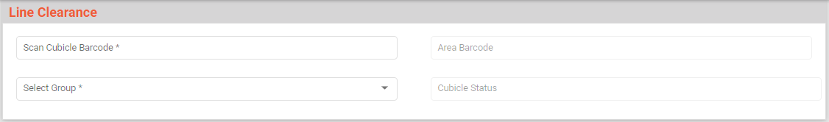

Picking
Activities
Module Description | The Module will be used to Pick material from Location and place in Pre stage area.

Pre-Conditions | - Group should be created.  - Material should be allocated in location.

Process Steps | - Scan/Enter the Cubicle Barcode.  *The material location gets fetched for Dispensing.  - Select the Group from the dropdown list.  - Select Material Code and SAP Batch No. from drop down list.  - System will display Location from where user can pick the material.  - The required Quantity and Bin details get displayed in columns.  - Then user will reach to the location and Scan Location Barcode to verify the location from where user will pick the material.  - System will validate the Suggested location and Scanned location are matching.  - Scan Material Barcode on the container.  - System will validate Expiry Date, Retest date,  - Material is approved.  - System validated and display Container Count and Quantity.  - Picking status gets displayed after all selection.  - Click on Complete and then system.  - System will allow picking for next material.

Post-Conditions | - Material is placed in Pre Stage area.  - Picking is completed.

Validations | - An alert should be displayed in case duplicate/ invalid Cubicle Barcode is selected.  - An alert message is displayed in case of any error / invalid activity.  - System will validate the Suggested location and Scanned location are matching.  - System will validate Expiry Date, Retest date, Material is approved and also it is as per Material and SAP batch no selected.  - Cubicle scanned will be validated as cubicle is assigned or not.  - An alert should be displayed in case duplicate/ invalid Material Barcode is selected.  - Group wise saving will be done.  - System will not allow to pick less than required quantity.  - While saving if all materials are not picked then system will not allow saving and also display which material is pending.

Sample Screen Design | 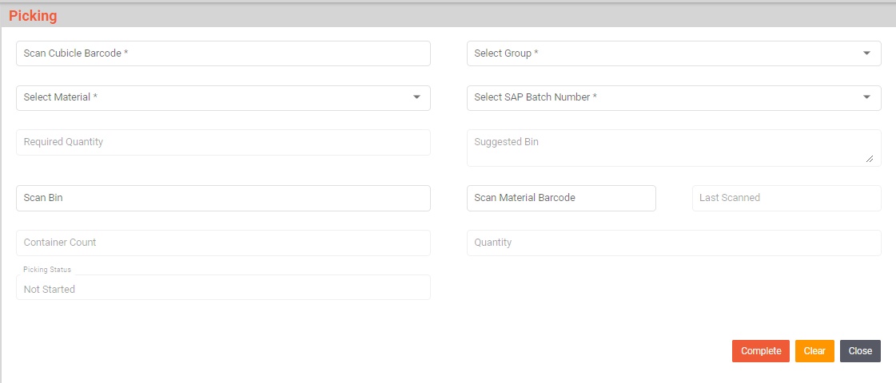

Pre Stage
Activities
Module Description | This module will be used to validate material movement from pre staging area to Dispensing booth.

Pre-Conditions | - Material Picking should be completed.  - Material should be placed in Pre Stage area.  - Line of Cubicle/Material should be completed.

Process Steps | - Scan Cubicle Barcode.  - Select Group, Material, and SAP Batch No. from the dropdown.  - User will scan the Material Barcode which is to be pre stage.  - System will validate whether the scanned material barcode is picked for that particular cubicle or not.  - System will updated as status as Material Pre staged.

Post-Conditions | - Material Pre Stage is completed.  - Material is available for staging.

Validations | - An alert should be displayed in case duplicate/ invalid Material Barcode is selected.  - Only picked material can be scanned in Pre Stage.  - System will allow only multiple material at a time in staging.

Sample Screen Design | 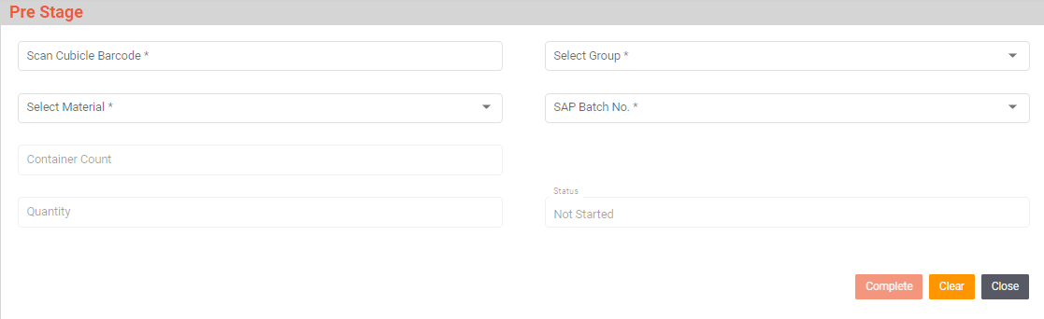

Staging
Activities
Module Description | This module will be used to validate material movement from staging area to Dispensing booth.

Pre-Conditions | - Material Picking is completed and material is placed in Staging area.  - Line of Cubicle/Material to be completed.

Process Steps | - Scan the Cubicle Barcode.  - System will display Group, Material, and SAP Batch No. for which staging is completed.  - Scan the Material Barcode.  - System will validate whether the scanned Material Barcode is picked for that particular cubicle or not.  - System will updated as status as material staging Completed.

Post-Conditions | - Material staging is completed.

Validations | - An alert should be displayed in case duplicate/ invalid Material Barcode is selected.  - Only pre staged material can be scanned in Staging.  - System will allow only one material at a time in Dispensing booth.

Sample Screen Design | 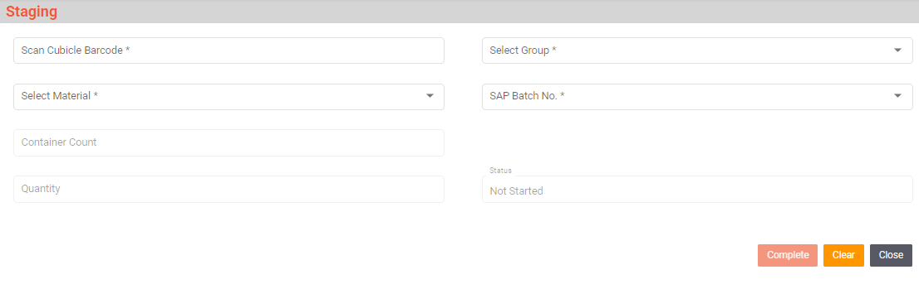

Dispensing
Activities
Module Description | This module will be used to Dispensed material which is to be issued to Production department.

Pre-Conditions | - Staging of the material should be completed.

Process Steps | - Scan the RLAF Barcode.  - Select Process Order No/Reservation No, Select Material Code, SAP Batch No from dropdown.  - Select SAP Batch No.  - System will display Required Quantity and Balance Quantity.  - Enter Required No of Containers.  - Scan Material Barcode which is to be dispensed.  - System will validate Expiry Date, Retest date, Material is approved and also it is as per Material and SAP batch no selected.  - User will Scan balance for initial reading.  Initial reading will be set to zero.  - User will select the UOM for dispensing.  - System will display Weighing Balance code belonging to that dispensing booth.  If the UOM selected is KG,MG,G then system will displayed GROSS, NET and TARE on screen to capture weight from balance and display accordingly and if the UOM is L,ML, EA, TH then system will display No of packs where user will pack quantity manually.  - Scan weighing balance barcode and system will capture weight from balance through LAN.  - Weighing Process:  - Standard Weighing  - User will keep the empty poly bag on the weighing balance and then scan the barcode on the weighing balance containing Weighing ID system will capture the weight displayed on the weighing balance and store as Tare wt.  - Then user will put the material in the poly bag and as it reach the require weight then scan the weighing balance barcode and system stores the Gross Wt. and calculate the Net wt.  - Gross Weighing  - User will keep the intact container on the weighing balance and check mark the Gross tab on the screen.  - Then scan the weighing balance barcode and system stores the Gross wt.  - Then user will enter Net wt. or Tare wt. system will calculate accordingly and display Gross, Net and Tare wt. on the screen.  - Packing label printing for No. of Packs Label  - While doing dispensing for no. of packs, system will display enter no. of packs  - The No. of packs dispensing will be decided as per the UOM mentioned in the Process order for “issue quantity UOM” (each).  - Then user will enter the no of packs  - Then click on Print button then pop of User ID and Password authentication will be displayed.  - Production person having authorization will be allowed and Dispensed label will be printed.  - Net quantity or Issue quantity will deducted from balance quantity,  System will allow multiple dispensing for the material till the balance quantity not equal to zero.  - Click on Weighment Done By button.  - User will click on Complete button.  - System will note the dispensing stop time in area and usage log.  - Select printer from dropdown.  - Click on Print button to take the printout.

Post-Conditions | - Dispensed material will be palletized.  - Loose container will reallocated at location.

Validations | - An alert should be displayed in case duplicate/ invalid RLAF is selected.  - System will validate Expiry Date, Retest date, Material is approved and also it is as per Material and SAP batch no selected.  - Multiple scanning of same material barcode will be allowed till the material container quantity is balance.  - An alert should be displayed in case of invalid activity.

Sample Screen Design | 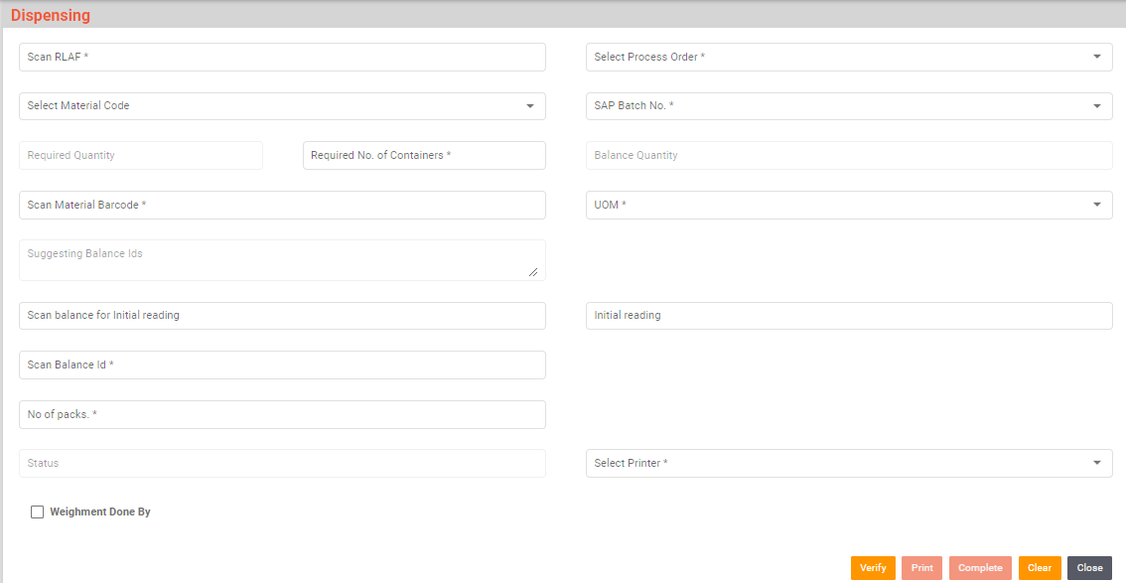

Issue to Production(PENDING)
Activities
Module Description | This module is used to issue the

Pre-Conditions | - Dispensing should be completed.

Process Steps

Post-Conditions

Validations

Sample Screen Design | 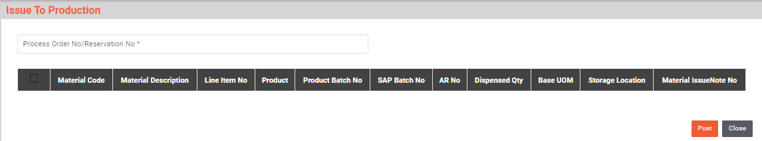

Stage Out
Activities
Module Description | This module will be used stage out the Loose Material.

Pre-Conditions | - Dispensing is completed.

Process Steps | - Scan the Cubicle Barcode.  - Select Group, Select Material, SAP Batch No from dropdown.  - Scan Material Barcode.  - Container Count, Quantity, Status will appear on screen.  - Then scan the loose material which is to be reallocated.  - After completing scanning of all containers click on Complete button.

Post-Conditions | - Reallocate the material to Put Away locations.

Validations | - An alert should be displayed in case duplicate/ invalid Material Barcode is selected  - Only Loose material can be scan in stage out.

Sample Screen Design | 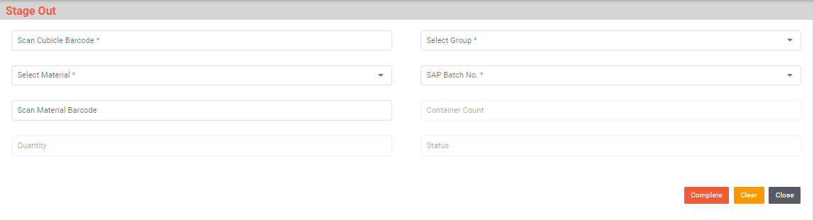

Put Away
Activities
Module Description | This module will be used to map Pallets to Bins and Material to Bins.

Pre-Conditions | - Stage out should be completed.

Process Steps | - Select the type of Put Away i.e. Pallet to Bin or Material to Bin.  - Enter/Scan Bin Barcode.  - Enter/Scan Pallet or Material Barcode.  - Scan count will appear on the screen.  - Putaway details added successfully.  - A grid format of Bin Barcode, Material Description, SAP Batch No, and Container No will appear on the screen.  - Click on Complete Button.  - A grid format of Bin Barcode, Pallet Barcode, Material Code, Material Description, SAP Batch No, Count, and Action will appear on the screen.  - Data is saved in database.

Post-Conditions | - Pallet or Material Put Away is completed.

Validations | - An alert should be displayed in case duplicate/ invalid Bin Barcode is entered.  - An alert should be displayed in case duplicate/ invalid Pallet Barcode is entered.  - An alert should be displayed in case duplicate/ invalid Material Barcode is entered.

Sample Screen Design | 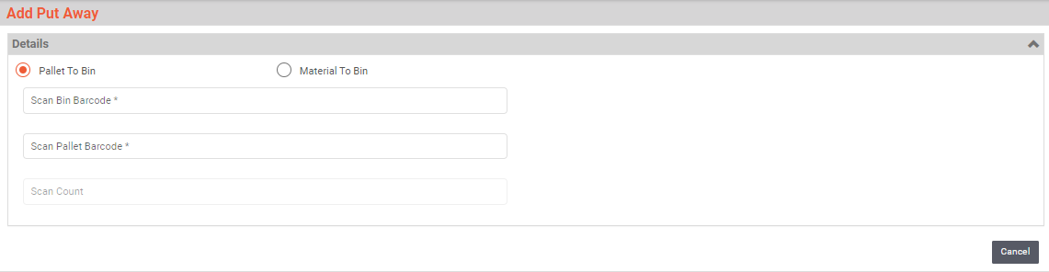

Return To Vendor
Activities
Module Description | This module will be used return the rejected material to vendor

Pre-Conditions | - Material is rejected.  - Material document generated in SAP and transferred to PMMS application database

Process Steps | - User will login in the PMMS device application.  - In Menu click on “Return to Vendor”  - System will display Return to vendor screen  - Enter/Select the material document generated in SAP.  - Details will be displayed on screen Material Code, Material description, SAP Batch No., A.R. No., Quantity, UOM and Vendor Name.  - User will scan Material barcode.  - System will validate the material is rejected or not.  - Then after completing scanning of all material barcodes, user will click on “Post” to confirm SAP that return to vendor is completed.

Post-Conditions | - Dispatch the material containers to vendor

Validations | - Duplicate scanning of material barcode will not be allowed.  - Only rejected material can be scan.

Sample Screen Design | 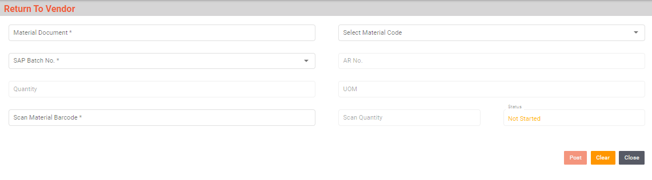

Destruction
Activities
Module Description | This module will be used destroy the rejected material.

Pre-Conditions | - Material is rejected.

Process Steps | - User will login in the PMMS device application.  - In Menu click on “Destruction”  - System will display Destruction screen  - Enter/Select the movement type (555/551) from the list.  - 555- removal from rejected stock  - 551- removal from approved stock.  - User will scan Material barcode.  - Details will be displayed on screen Material Code, Material description, SAP Batch No., A.R. No., Container Quantity, UOM.  - System will validate the material is rejected or not.  - Then after completing scanning of all material barcodes, user will click on “Post” to confirm SAP that Destruction is completed.

Post-Conditions | - Destroy the material containers.

Validations | - Duplicate scanning of material barcode will not be allowed.  - Only rejected material can be scan.

Sample Screen Design | 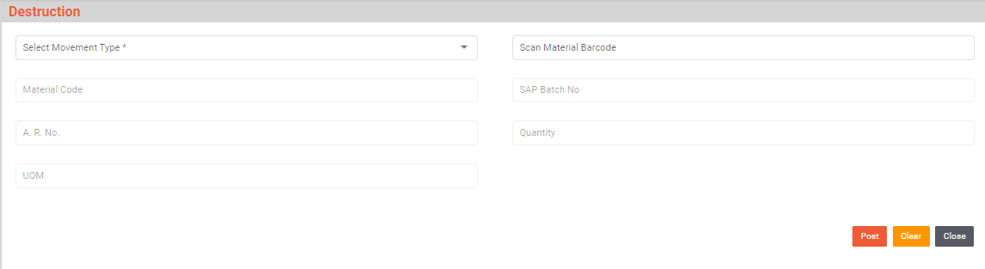

Weighing Balance Calibration And Verification
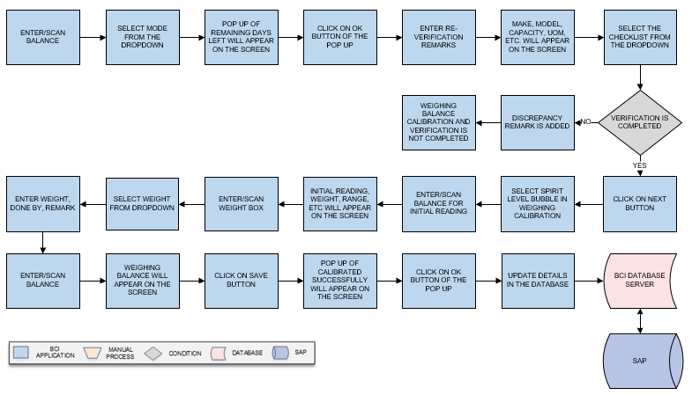
Activities
Module Description | This module will be used for calibration of Weighing Balance.

Pre-Conditions | - Weighing Balance master should be available.

Process Steps | - Enter/Scan Balance.  - Select Mode from the dropdown.  - Pop up of Remaining Days Left-- (Stamping is due for selected weighing machine) will appear on the screen.  - Click on Ok button of the Pop up.  - Enter Re-verification Remarks.  - Make, Model, Capacity, Unit of Measurement, Least Count, Reference SOP No, Format No, and Version will appear on the screen.  - Select the Checklist from the dropdown.  - If the weighing calibration is not ok:  - Discrepancy remark is added.  - Weighing Balance Calibration and Verification is not completed.  - Click on Next button.  - Select Spirit level bubble in Weighing Calibration.  - Enter/Scan balance for initial reading.  - Initial reading, Calibration Level, Weight, Range will appear on the screen.  - Enter/Scan Weight Box.  - Select weight from dropdown.  - Enter Weight, Done By, Remark.  - Enter/Scan Balance.  - Weighing Balance will appear on the screen.  - Click on Save button.  - Pop up of Weighing Machine Calibrated Successfully will appear on the screen.  - Click on Ok button of the Pop up.  - Data is saved in database.

Post-Conditions | - Weighing machine calibration and Verification is completed.

Validations | - An alert should be displayed in case of invalid activity.  - An alert should be displayed in case of Initial reading will not set to zero.

Sample Screen Design

SRS Scope Change Process

Before Sign Off
Any changes in SRS need to be informed in writing by Ajanta Pharma. It will be incorporated / confirmed only after doing detailed feasibility study by BCI.
- If any change is out of scope then this would be done as a CR post feasibility and priority will be decided based on mutual agreement.
- Once the change is developed , any further change in the same would be considered as a CR

After Sign Off
Any changes in proposed solution after approval of this document by Ajanta Pharma are subjected to confirmation from BCI, taking feasibility constraints into account. These changes will be incorporated (if any) into the solution only after delivering proposed solution & may be charged as extra.
- Any change in the proposed solution due to customer system design or process will be considered as CR
- Any process which is not mentioned in this document will not be considered as “mutual understanding or default presence or standard practice”.
The changes in proposed solution before & after acceptance will be mutually agreed and duly signed and accepted by Ajanta Pharma & BCI.

SRS Acceptance
For Ajanta Pharma | For Bar Code India (BCI)
Name: | Name:
Designation: | Designation:
Department: | Department:
Agreed and Accepted by Ajanta Pharma and Bar Code India.

